Mini project
Batch no: DA TE-008
Faculty: Sunitha.v
Student name: M Nithin
Dataset link: https://data.telangana.gov.in/dataset/tgspdcl-ev-charging-stations-consumption-data

Project title: TGSPDCL EV Charging Stations Consumption Analysis Telangana
Data Cleaning:
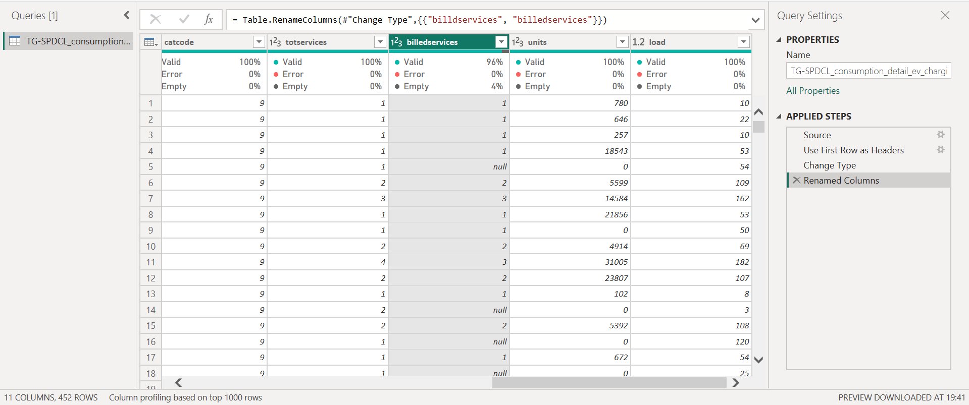
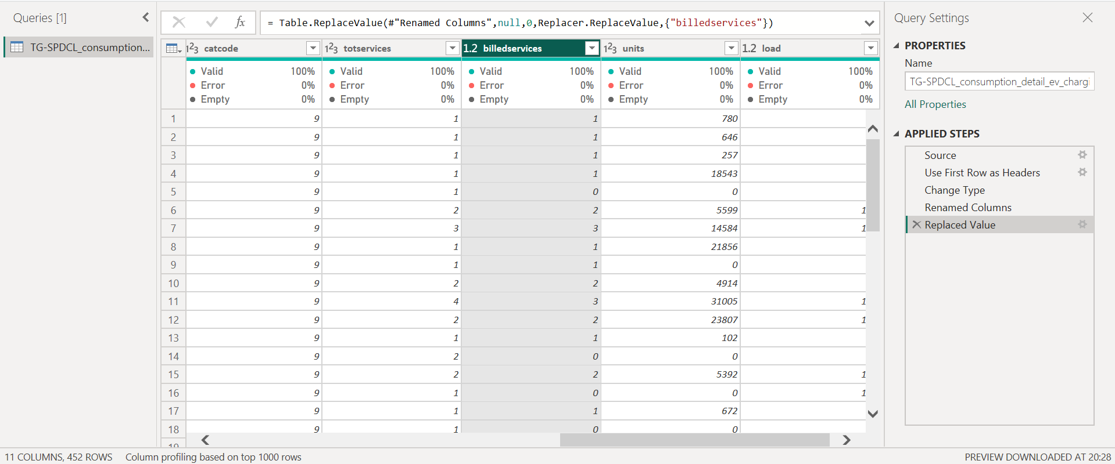

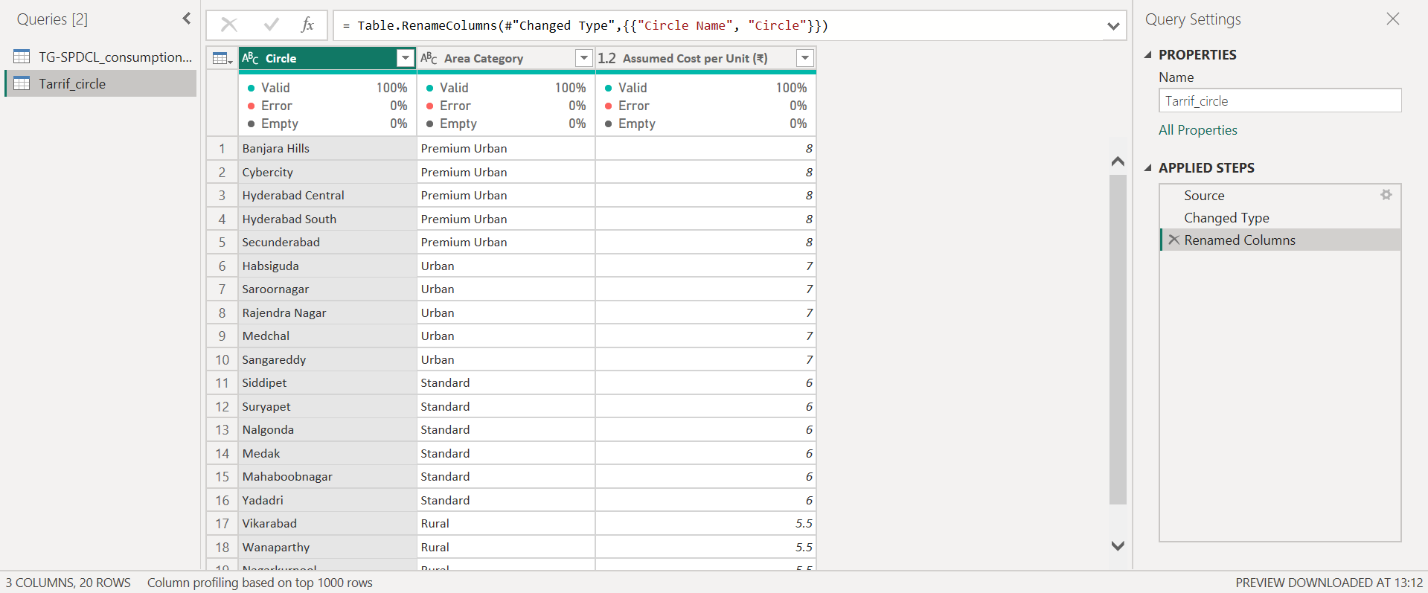
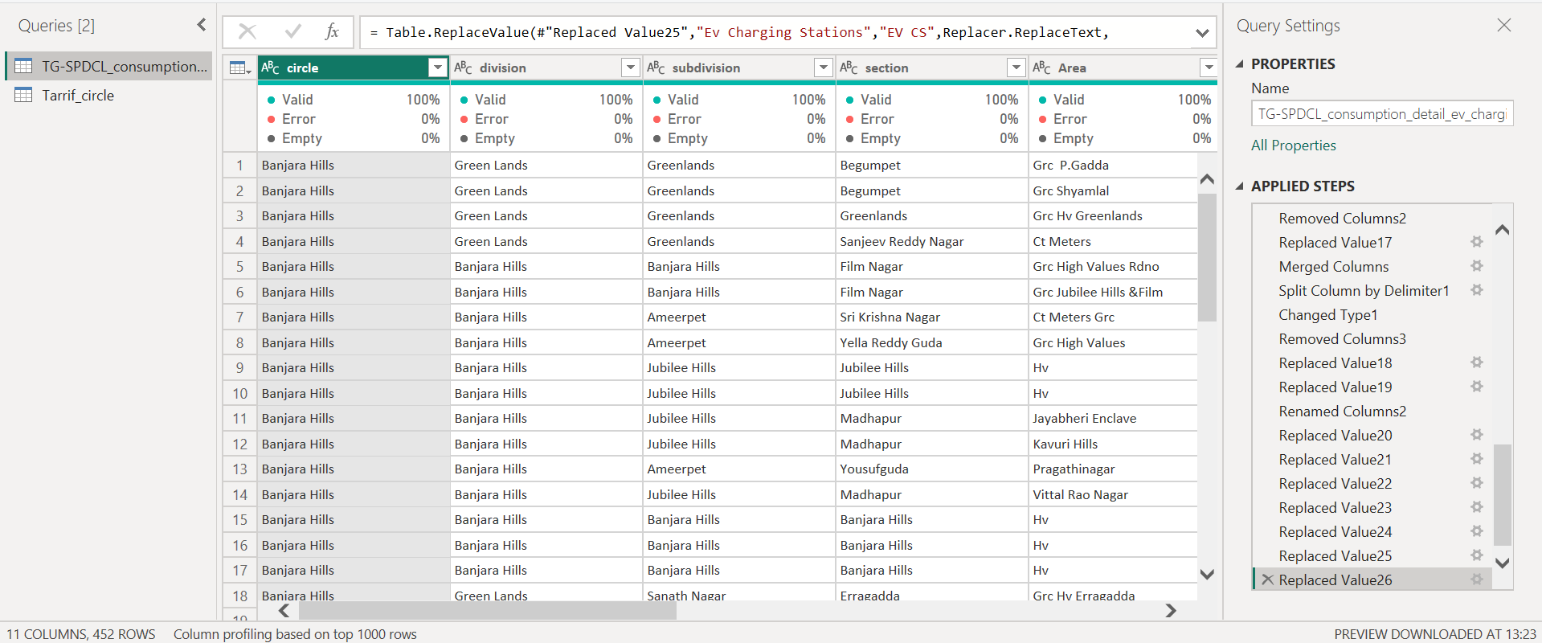
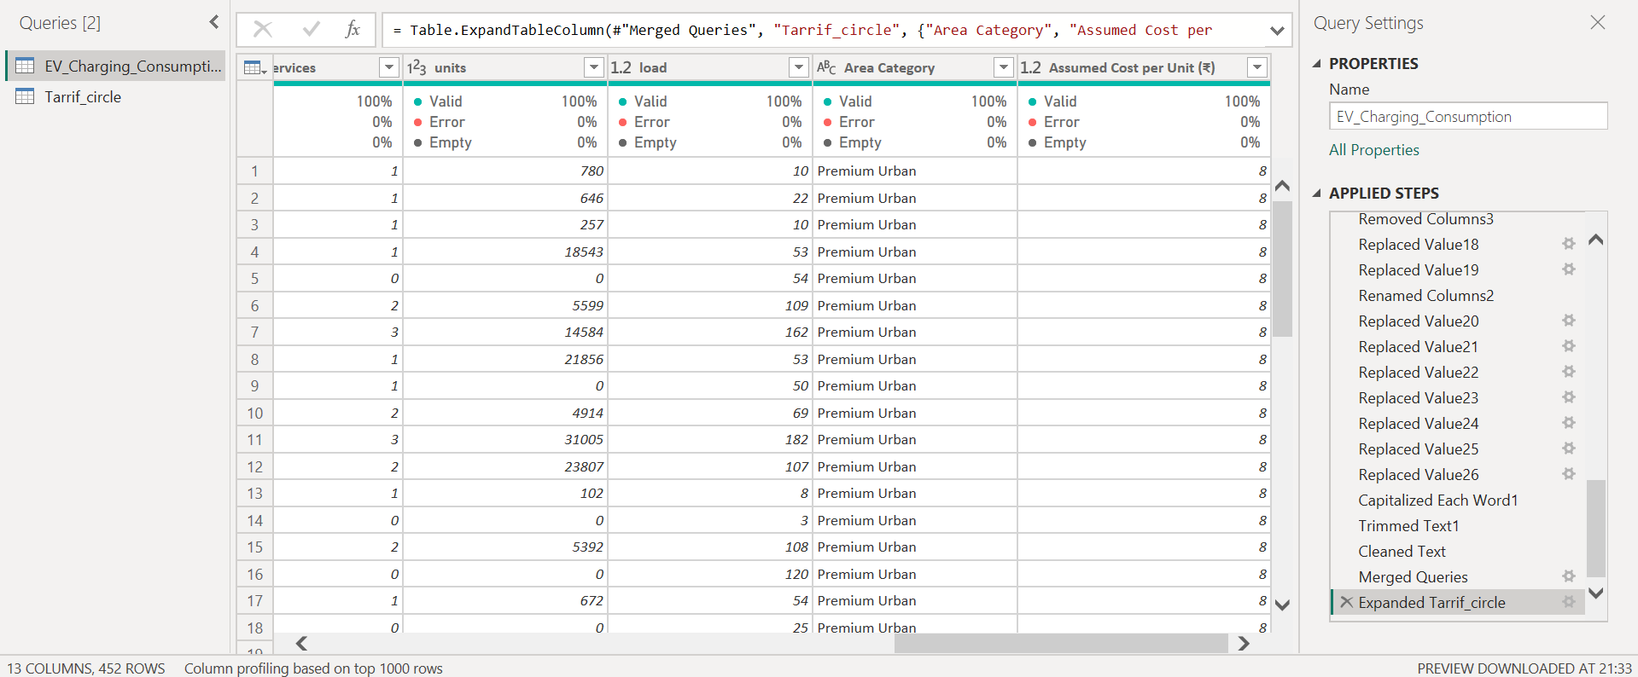
Conclusion:
The dataset was cleaned and prepared before creating the dashboard to ensure accurate analysis. Missing values and duplicate records were checked and removed. Data types were corrected so that numeric fields like units, revenue, and load could be properly calculated. Column names and category values such as circle, subdivision, and area category were standardized for consistency. Finally, unnecessary columns were removed and required DAX measures were created to support dashboard KPIs and visualizations.

